Outline:

- Unit Root Test:
  - Graphical (Linear Term ACF, PACF)
  - Formal (ADF, Phillips/Peronas, KPSS)
- ARMA/GARCH
- Normality Tests (Using simple return):
  - Graphical (QQ-plots, Histogram)
  - Formal (Jarque–Bera test, Kolmogorov–Smirnov test)
- Fractional Integrated Tests:
  - Graphical (Aggregated Variance, Periodogram(log), ACF(log-log, Regular, R/S))
  - Formal (GPH, Spiero, Whittle)
    - d-parameter estimation
    - d-parameter confident interval using Monte Carlo Simulation. (Random normal & Resample)
    - Repeat until d = 0
- Model Fitting (GARCH, ARMA)
- Model Checking (Forecasting error)
- Simulation
plots
- Unit Root Tests
  - Graphical
    - Linear Trend in ACF

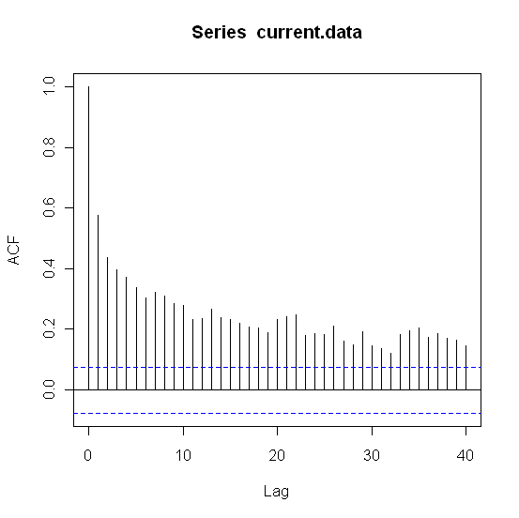

  - Formal
    - ADF w/ lag = 4 (H_{o}: y_{t} ~ I(1), unit root stationary, H_{a}: y_{t} ~ I(0), non unit root stationary)

      - ADF – C
        - Test Statistic = -6.3211
        - P-value = 0.01

      - ADF – NC
        - Test Statistic = -0.3217
        - P-value = 0.5138
      - ADF – CT
        - Test Statistic = -6.6711
        - P-value = 0.01

    - Phillips – Perron (H_{o}: y_{t} ~ I(1), unit root stationary, H_{a}: y_{t} ~ I(0), non unit root stationary)
      - Test Statistic = -14.568
      - P-value = 0.01
      - Truncation lag parameter = 6
    - KPSS (H_{o}: y_{t} ~ I(0), non unit root stationary, H_{a}: y_{t} ~ I(1), unit root stationary)
      - Short truncation lag
        - KPSS Trend = 0.2972
        - P-value = 0.01
        - Truncation lag parameter = 5
      - Long truncation lag
        - KPSS Trend = 0.1437
        - P-value = 0.0542
        - Truncation lag parameter = 18

- ARMA / GARCH
  - ARMA(2,1)

Call:
arima(x = current.data, order = c(2, 0, 1))

Coefficients:
ar1 ar2 ma1 intercept
1.2762 -0.3002 -0.8531 11.4878
s.e. 0.0715 0.0610 0.0537 0.1610

sigma^2 estimated as 0.4878: log likelihood = -703.14, aic = 1416.29

  - GARCH(1,1) with ARMA(2,1)

Maximum Likelihood Estimation (Std.Errors based on Second derivatives)
Coefficient Std.Error t-value t-prob
Cst(M) 11.524248 0.11912 96.75 0.0000
AR(1) 1.000000 1.2918 0.7741 0.4391
AR(2) -0.106731 0.82108 -0.1300 0.8966
MA(1) -0.543666 1.4092 -0.3858 0.6998
Cst(V) 0.184434 0.13202 1.397 0.1629
ARCH(Alpha1) 0.142997 0.060934 2.347 0.0192
  - GARCH(Beta1) 0.488994 0.28470 1.718 0.0863

- Normality Tests

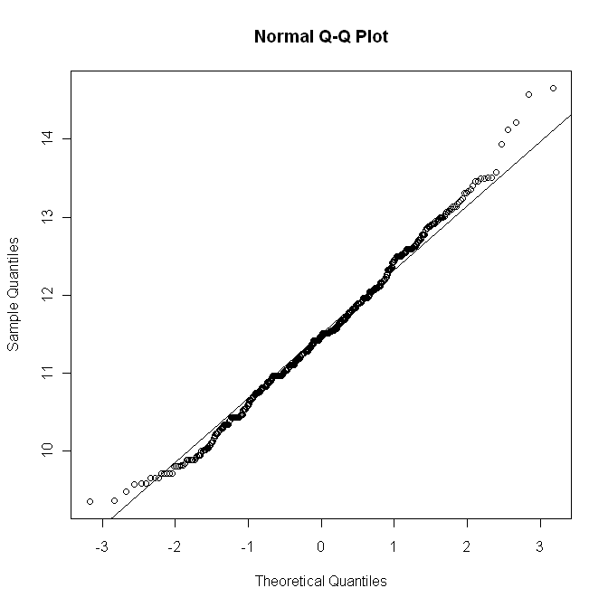
Original Nile data:
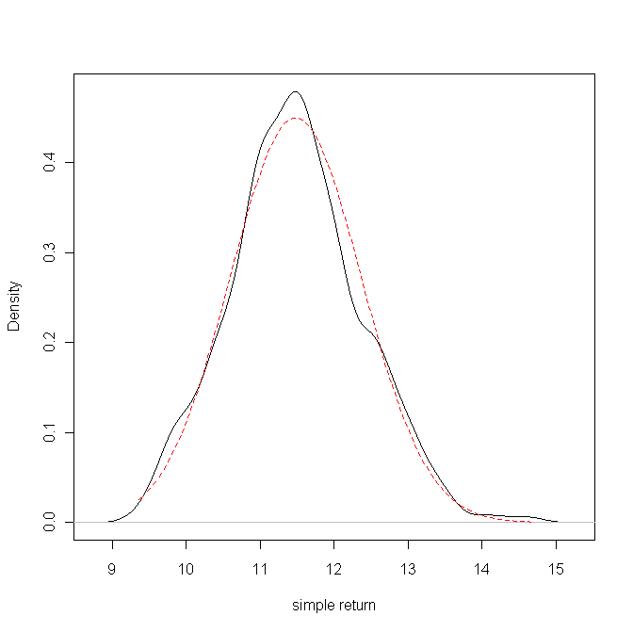

Nile simple returns:
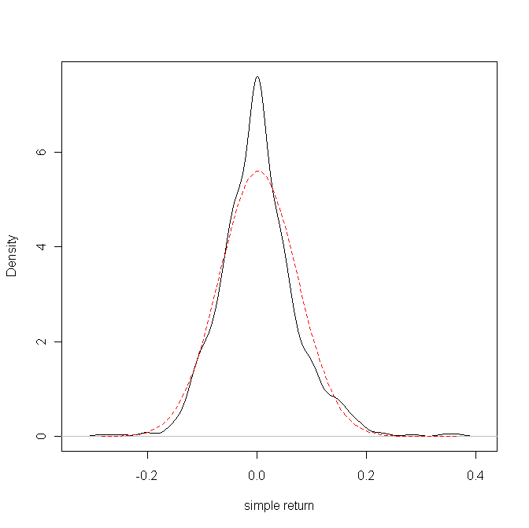
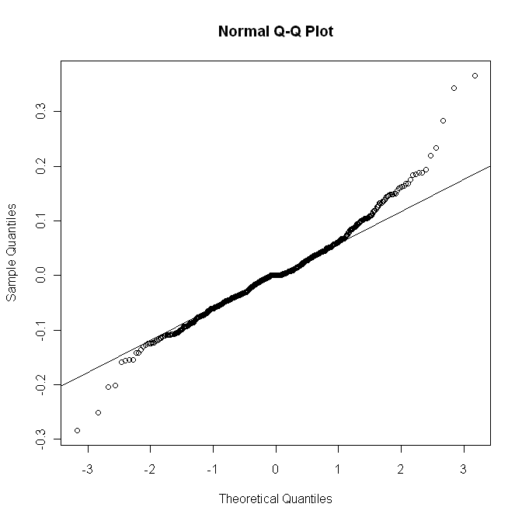

Simulated N(0,1) Data, 662 Observations:
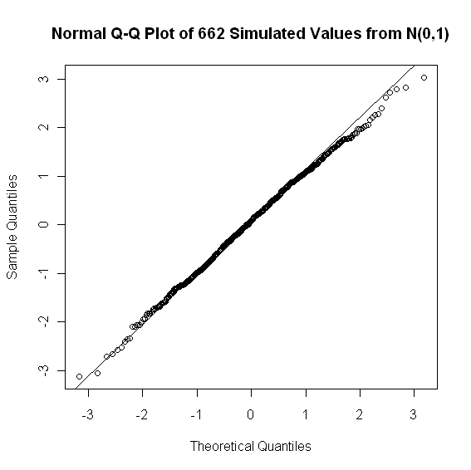

Statistical Tests:

1) Shapiro-Wilk Normality Test

Test Results:
STATISTIC: W : 0.9933
P VALUE: P : 0.004614

2) Jarque - Bera Normalality Test

Test Results:
STATISTIC: X-squared : 6.8061
P VALUE: Asymptotic Value : 0.03327

3) D'Agostino Normality Test

Test Results:
STATISTIC: Chi2| Omnibus : 6.9094
Z3 | Skewness : 2.5507
Z4 | Kurtosis : 0.6349
P VALUE: Omnibus Test : 0.0316
Skewness Test : 0.01075
Kurtosis Test : 0.5255

4) Lilliefors (KS) Normality Test

Test Results:
STATISTIC: D (value) : 0.0439
P VALUE: P (value) : 0.004084

- Fractional Integrated Tests
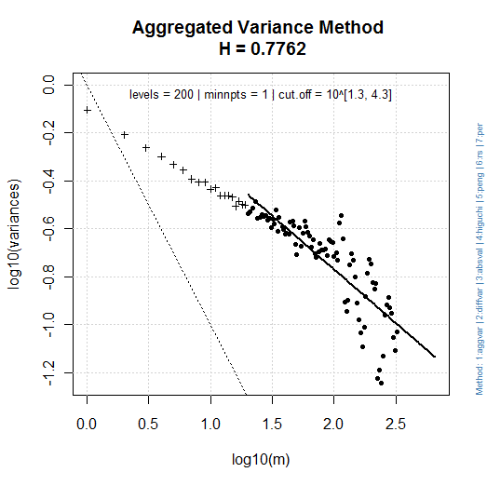 | 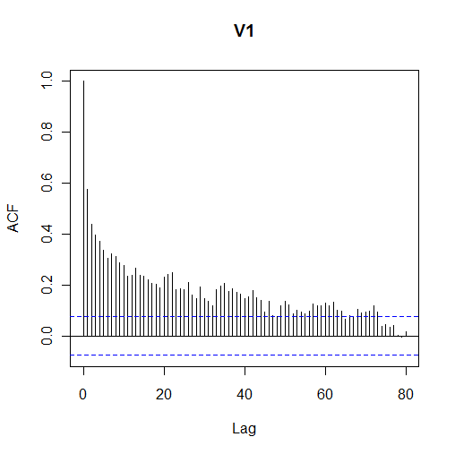
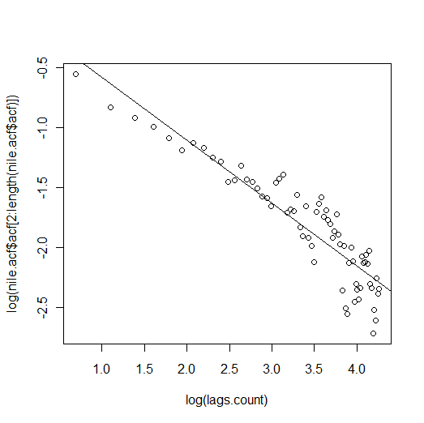 | 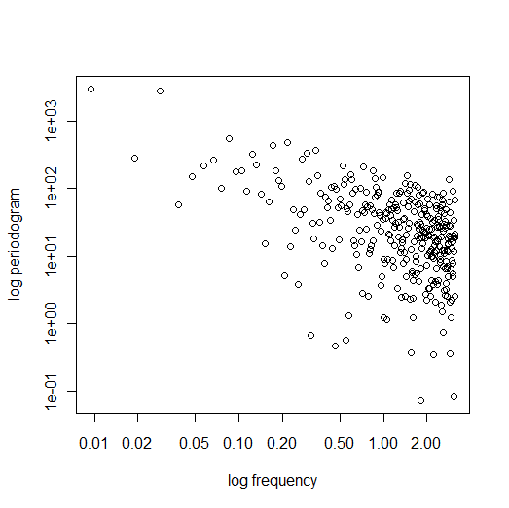
  - Graphical
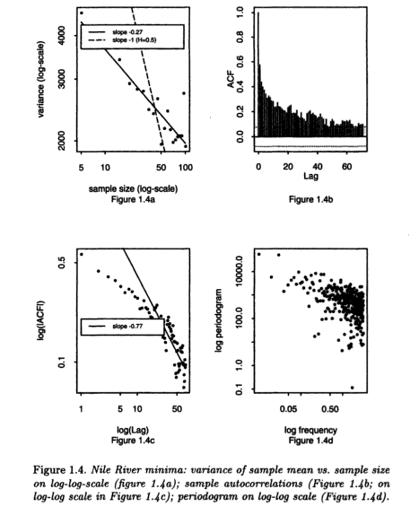
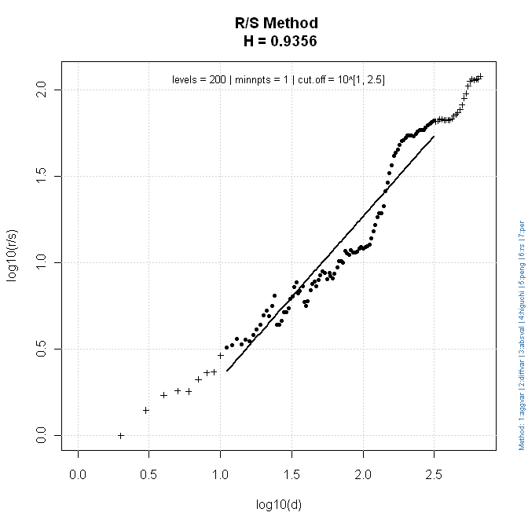

b) Whittle Fit:

1) FGN

Results: theta = 0.09854012 0.837425
H = 0.837425 => (d = 0.337425)
95%-CI for H : [ 0.7864071 , 0.888443 ]

2) FARMA

Results: theta = 0.0989124 0.8991992
H = 0.8991992 =>(d = 0.3991992)
95%-CI for H : [ 0.839536 , 0.9588624 ]

“d” Sperio estimate : 0.4427007

“d” fractionally diff. series : -0.006904546

Re-estimation of the H-parameter of the fractionally differenced series using “d” values estimated by “FGN” and “FARMA” whittle fits.

1) FGN Whittle Fit (“d” = 0.337425)

Results: theta = 0.1580748 0.5559218
H = 0.5559218
95%-CI for H : [0.5076023 , 0.6042414 ]

2) FARMA Whittle Fit (“d” = 0.3991992)

Results: theta = 0.1589146 0.49875
H = 0.49875
95%-CI for H : [ 0.4390869 , 0.5584131 ]

- Simulation

“d” = 0.5038294

Sperio "nile"
Observed data estimate : "0.442700666499865"
Simulated data estimate : "0.410441156669601"
Simulated CI 95% : [0.166567412317371 , 0.665081876086621]

Farma "nile"

Observed data estimate : -0.273320312500000
Simulated data estimate : 0.0542947265625001
Simulated CI : [-0.30862109375 , 0.367822265625]

